PO BOX 26

ST FRANCIS BAY, 6312

TEL: CHAIRMAN RICHARD FULFORD

082-990-7225

TEL: SECRETARY LAURA ROBSON

084-383-7098

[info@sfb-skiboatclub.co.za](mailto:info@sfb-skiboatclub.co.za)

**PORT ST FRANCIS SKI BOAT AND YACHT CLUB**

**MEMBERSHIP APPLICATION FORM**

|  |  |
| --- | --- |
| FULL NAME: |  |
| I.D. NUMBER: |  |
| OCCUPATION: |  |
| TELEPHONE NO. - CELL |  |
| TELEPHONE NO. - OTHER |  |
| E-MAIL ADDRESS: |  |
| POSTAL ADDRESS: |  |
|  |  |
| PHYSICAL ADDRESS: |  |
|  |  |
| ST FRANCIS ADDRESS: |  |
|  |  |
| BOAT NAME & NUMBER: |  |
| SKIPPERS & RADIO NO: |  |
| NEXT OF KIN & TEL NO.: |  |

|  |  |  |  |  |
| --- | --- | --- | --- | --- |
| MEMBERSHIP FEE: (Includes Family Card) | |  | 1500 |  |
| CAPITATION FEE: (Affiliation with SADSAA/EPDSAA) | |  | 340 |  |
| JUNIOR MEMBERS:  Juniors whose parents are Non-Members Capitation Fee Incl) | |  | 500 |  |
| STUDENT MEMBERS:  Juniors whose parents are Non-Members Capitation Fee Incl) | |  | 650 |  |
| **LAUNCH FEES (PAYMENT TO HARBOUR MASTER’S OFFICE)** | | 600 |  |  |
| SAILING FEES | |  |  | T.B.A. |
| TOTAL |  |  | | 0 |

|  |  |
| --- | --- |
|  |  |

|  |  |  |  |
| --- | --- | --- | --- |
| INTRODUCED BY: |  | SECONDED BY: |  |

|  |  |
| --- | --- |
| DATE |  |

**BANKING DETAILS:**

Port St Francis Ski Boat and Yacht Club

Standard Bank

Humansdorp Branch

Account No.: 082492514

**SAILING MEMBERSHIP FEES**

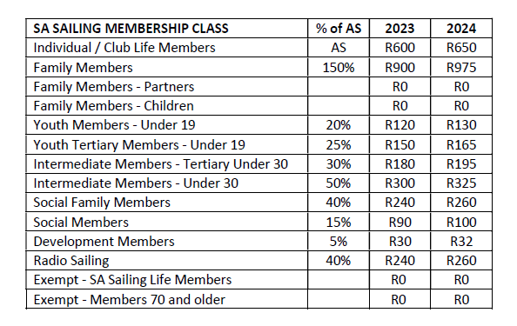

PLEASE RETURN VIA E-MAIL WITH YOUR PROOF OF PAYMENT TO:

[laura@stfrancisyamaha.co.za](mailto:laura@stfrancisyamaha.co.za)